

**PUBLIC TRANSPORT – REGULATIONS EXPLAINED (XHOSA)**

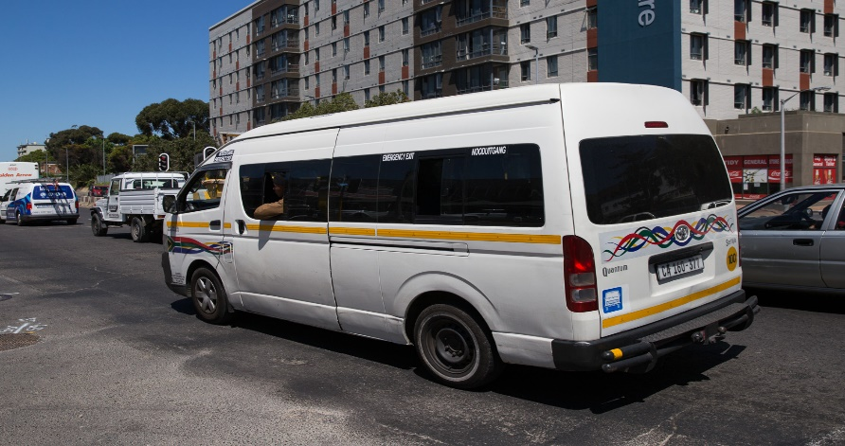

[This Photo](https://www.groundup.org.za/article/minibus-taxis-time-form-cooperatives/) by Unknown Author is licensed under [CC BY-ND](https://creativecommons.org/licenses/by-nd/3.0/)

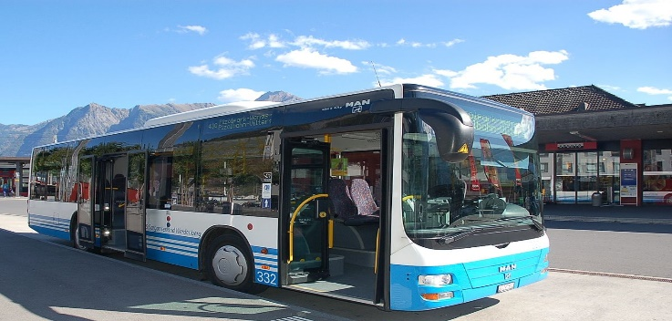



Kule vidiyo, sixoxa ngotshintsho olutsha kwimigaqo ebekiweyo yokulawula ilockdown (level 3). Sizo thetha ngotshintsho olubandakanya imvume esuka khu rhulumente uba abantu banga hambha besuka kwelinye iphondo besiya kwelinye ngokuvumekileyo.

* Abantu abavumelekileyo uba ba hamabhe besuka kwelinye iphondo besiya kwelinye (uba banayo imvume efunekayo) nga bantu abafudukela kwindawo entsha yokuhlala, abantu abakhathalela umntu osondeleyo wosapho, abafundi okanye abafundi abamele ukuya nokubuya kwezo zikolo okanye kumaziko emfundo ephezulu ngeloxesha apho zither zavunyelwa uba zivule, ukuzimasa imingcwabo, ukuhambisa izidumbu, ukufumana unyango, abantu ababuyela kwindawo zabo zokuhlala besuka kwi quarantine, kunye nokuhamba kwabantwana.
* Bonke abanini bezithuthi zothutho lukawonkewonke kunye namancedo kufuneka baqhubeke ngokubeka amanyathelo .Bamele bazicoceke rhoqo izithuthi zabo kwaye babonelele ngesixhobo sokucocwa kunye nokubulala iintsholongwane kubasebenzisi njengoko bekufuneka benze njalo ngaphambili. iiSanitisers ezisetyenzisiweyo kufuneka zibe nomxholo wotywala we-60% okanye ngaphezulu.
* Bonke abaqhubi bezi thuthi, abasebenzi bezokhuseleko, abahamba ngee teksi kunye nabakhweli kufuneka banxibe imask yobuso okanye ilaphu eligubungela impumlo kunye nomlomo.
* Amaxesha othintelo kuzo zonke iindlela zothutho lukawonkewonke asusiwe. Izithuthi zikawonkewonke ngoku ziya kuvunyelwa ukuba zisebenze imini yonke. Nangona kunjalo, izithintelo zamanani akheliswayo zisa hleli.
* iikhumbi, iiquantum nee teksi azi layishi inani elodlule u70% le nani labantu eqhele ubalayisha.
* iibhasi kufuneka zihambelane nomgangatho wokuu umthamo wabantu odlule u50% we nani lesi qhelo, kubandakanywa abakhweli abamileyo;
* Izithuthi ezi ncinci nje nge uber, iitaxify cabs ne meter cabs zingeno layisha umthamo wabantu abodlule u50%
* Onke amaZiko okuvavanya iilayisensi zabaqhubi, iZiko lokuVavanya iZithuthi kunye namaZiko oLawulo lwePhondo aza kuphinda aqhubeke ukusebenza nge-1 kaJuni 2020
* iizikolo zokuqhuba zinokuphinda zivule kodwa kufuneka zibeke amanyathelo ococeko.
* Zonke ilayisensi zabafundi, iilayisensi zokuqhuba, iidiski zeelayisensi zokuqhuba, iimvume zethutyana zokuqhuba eziphelelwe lixesha ukusuka nge-26 Matshi 2020 ukuya nge-31 kaMeyi 2020 (ibandakanyiwe), ziya kuhlala zisebenza ixesha elingangeentsuku eziyi 90 ukusukela nge-1 kaJuni 2020.
* iGautrain iza kuqhubeka noku hambhisa abantu kwi ndlela esuka ePark Station eya eHartfield ne suka eSandton eya eOR Tambo Airport. uPRASA ayika qali usebenza.