
PUBLIC TRANSPORT – REGULATIONS EXPLAINED (SESOTHO)

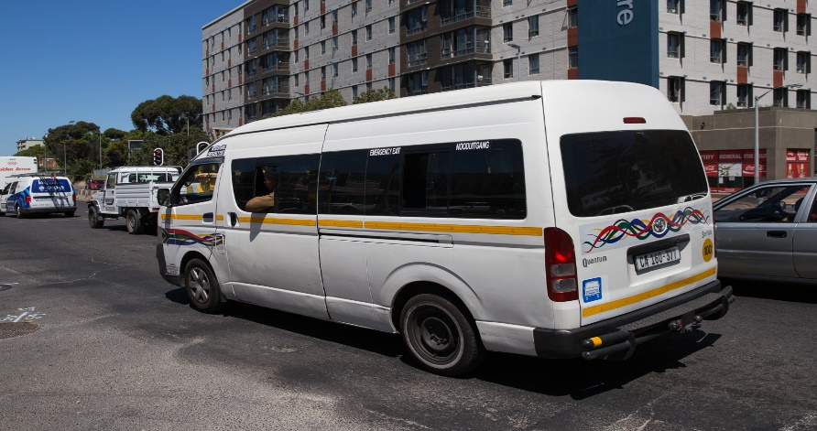
This Photo by Unknown Author is licensed under CC BY-ND

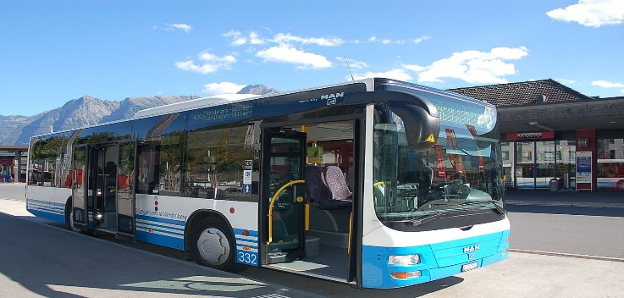



Ka tlasa kgatiso ena, re sekaseka diphetoho tsa morao-rao tse ka tlasa mokgahlelo wa boraro wa thibelo ya ho tsamaya ha batho ka bolokollohi e qadileng ka la 1 June 2020. Tseding tsa diphetoho di kenyelletsa tumello ya ho tsamaya mahareng a diprovense moo ho dumelletsweng ka tlasa mokgahlelo wa boraro.
- Batho ba dumelletsweng ho tsamaya mahareng a diprovense ba kenyelletsa basebetsi (ha feela ba tshwere lengolo la tumello ya ho tsamaya), batho ba yang tulong tse ntjha tsa bodulo, batho ba hlokomelang emong wa lelapa, barutwana ba yang dikolong tse dumelletsweng ho bulwa ka nako ena, ho ya mapatong, tsamaiso ya ditopo, ho fumana kalafo kapa thuso ya booekedi, batho ba kgutlelang malapeng ho tloha tulong tsa ho ikwalla thoko le tsamaiso ya bana.

- Bang ba dipalangwang tsa setjhaba ba tshwanetse ho beha melao ha mmoho le ho hlwekisa dipalangwang tsa bona ka sethibela dikokwanahloko kgafetsa mme ba fane ka sethibela dikokwanahloko ho bapalami ba bona. Sethibela dikokwanahloko se sebediswang se lokela ho ba le dipesentere tse mashome a tsheletseng tsa jwala.

- Bakganni ba dipalangwang, basebeletsi ba tshireletso, basebeletsi ba dipalangwang le bapalami ba tshwanetse ho apara setshireletso sa dinko le molomo kapa lesela le kwalang dinko le molomo ka nako tsohle.

- Dipalangwang tsa setjhaba di se di dumelletswe ho sebetsa ka nako tsohle tsa letsatsi empa thibelo ya bokgoni ba ho palamisa bapalami ba bangata e ntse e le teng.

- Bokgoni ba ho palamisa bapalami ba diminibus, midi-bus le ditekesi bo tla dula ho dipesentere tse mashome a supileng.

- Dibese di dumellwetse ho palamisa bapalami ba sa feteng dipesentere tse mashome a mahlano. Palo ena e kenyelletsa bapalami ba emeng ka maoto le ba dutseng fatshe.

- Dipalangwang tsa setjhaba tse tshwanang le diUber le taxify di dumelletswe ho palamisa batho ba sa feteng dipesentere tse mashome a mahlano.

- Ditulo tsa diteko tsa ho kganna le diteko tsa dikoloi di tla qala ho sebetsa ka 1 June 2020.

- Mangolo a ho kganna a boithuti, mangolo a ho kganna, dilaesense disk tsa makoloi, mangolo a tumello ya nakoana le mangolo a tumello ya ho kganna a felletsweng ke nako mahareng a 26 March 2020 le 31 May 2020 a tla dumellwa ho sebetsa matsatsi a mashome a marobong ho tloha ka la 1 June 2020.

- Terene ya Gautrain e tla tswella pele ka tsamaiso ya bapalami ho tloha Park Station ho fitlela Hartfield le ho tloha Sandton ho fitlela OR Tambo International Airport. Diterene tsa PRASA ha di so qale ditsebediso.

