
PUBLIC TRANSPORT – REGULATIONS EXPLAINED (ISIZULU)

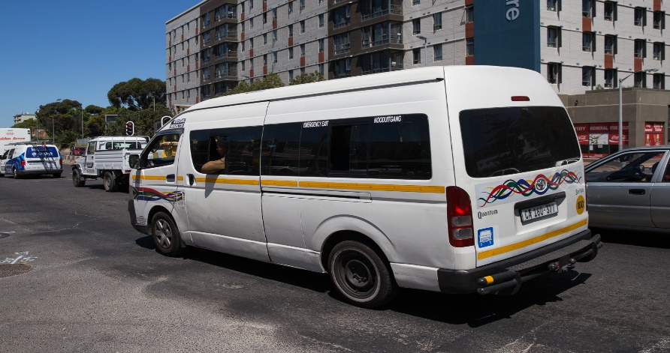
This Photo by Unknown Author is licensed under CC BY-ND

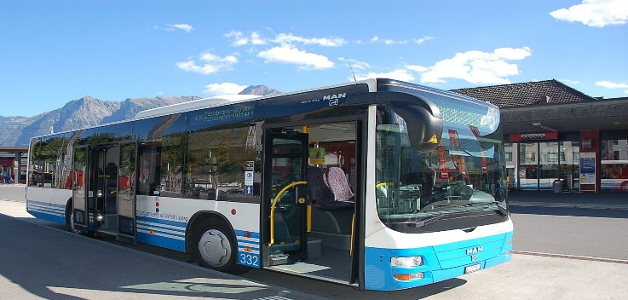



Kulesiqophi, sikhuluma ngoshintsho kwinqubo-mgomo ekhishwe ukuhola izinga lesithathu semvalelo kusukela ku1 Nhlangulana 2020. Ezinye zalezo zinguquko ngaphansi kwezinga lesithathu kwinqubo-mgomo zivumela uhambo phakathi kwezifundazwe.

- Abantu abavumelekile ukuhamba phakathi kwezifundazwe ngabantu abahambela umsebenzi, (uma bephethe imvume edingekayo), abantu abathuthela kwindawo entsha yokuhlala, abantu abanakekela ilunga lomndeni lozalo, abafundi abadinga ukuya ezikoleni noma kwizikhungo zemfundo eziphakeme kulezozikhathi lapho izikole noma izikhungo zemfundo eziphakeme zivunyeliwe ukusebenza, abaya emingcwabeni, abahambisa izidumbu, abayothola ukwelashwa, abantu abasuku ezindaweni zokuzivalele noma kwizindawo zokuhlala wedwa bephindela emakubo, nokuhambisa kwezingane.

- Bonke abanikazi bezimoto zokuthutha umphakathi nezindawo ezihlangene kumele baqhubeke ngokufaka izinyathelo ezindaweni. Kumele baphinde bahlanze izimoto zabo ngenjwayelo baphinde banike abasebenzisa izimoto zabo zomphakathi nezindawo ezihlangene izihlanzi zokuhlanza nokubulala amagciwane njengoba kwakufunekile ngaphambilini. Izihlanzi zandla zokuhlanza kumele zibe notshwala phakathi olingana namaphesenti angamashumi ayisithupha noma ngaphezulu.

- Bonke abashayeli, onogada, ababheki matekisi naba gibeli kumele baqhoke isivivu noma indwangu efihla ikhala nomlomo.

- Imikhawulo yesikhatha kuzozonke izinhlobo zezimoto zokhuthutha umphakathi iphakanyisiwe. Izimoto zokuthutha umphakathi zizovunyelwa ukusebenza phakathi nosuku. Kodwa, imikhawulo yabagibeli izohlala.

- Umthamo wokulayisha ovumelekile wamabhasi amancane, amabhasi akhundlwana, namatekisi uzohlala kwamaphesenti angamashumi nesikhombisa;

- Amabhasi kumele aqhubeka alandele umthamo wokulayisha ongadluli amaphesenti angamashumi amahlanu.

- Izimoto ezizimele eziqhuba umphakathi zizohlala kumthamo wokulayisha olingana namaphesenti angamashumi amahlanu.

- Zonke izikhungo zokuhlola izincwadi zokushayela, izikhungo zokuhlola izimoto nezinhlaka ezilawula izifundazwe zizobuyela emisebenzini ngomhlaka 1 Nhlangulana 2020.

- Izikole zokushayela nazo zingaphindela kwimisebenza kodwa kumele zifake izinyathelo zokuhlanza izakhawo.

- Zonke izincwadi zokufundela ukushayela, izincwadi zokushayela, amadiski elayisense yemoto, izimvume zokushayela okwesikhashana, izimvume zokushayela ochwepheshe ezaphelelwa yisikhathi ngokomthetho phakathi kuka 26 kuNdasa 2020 kuya ku 31 kuNhlaba 2020 (nazo lezinsuku zibaliwe) zizoqhubeka zibe emthethweni ngezinsuku ezilingana namashumi ayisishiyagololunye kusukela ku 1 Nhlangulana 2020.

- Isitimela, iGautrain, sizoqhubeka ukulayisha abagibeli kwimizila esuka ePark Station eya eHatfield kanye nesuku eSandton eya eOR Tambo International Airport. Isitimela somphakathi iPRASA asakabuyeli emsebenzini.

