
PUBLIC TRANSPORT – REGULATIONS EXPLAINED (ENGLISH)

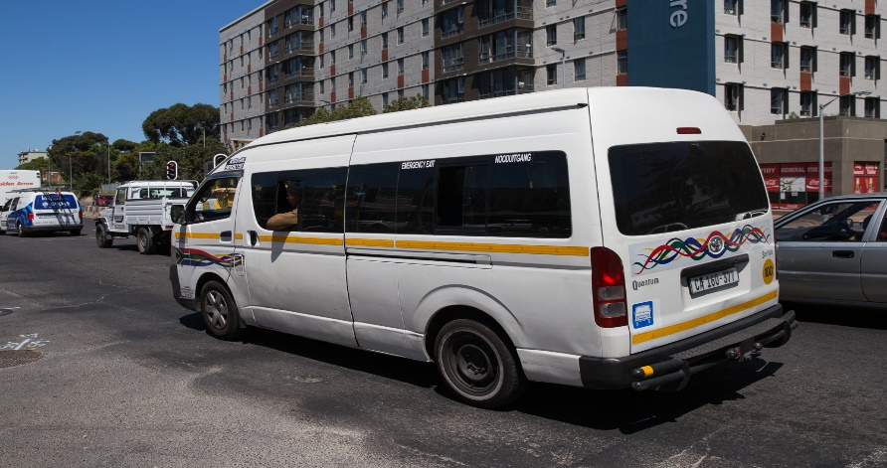
This Photo by Unknown Author is licensed under CC BY-ND

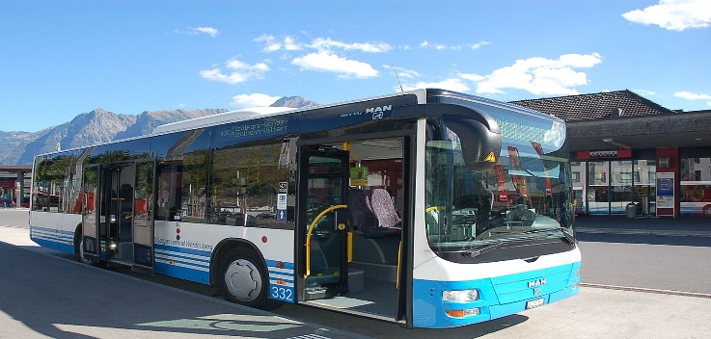



Provincial travel

Long distance public transport is now permitted to enable people to travel between provinces as permitted under level 3.

Under alert level 3, the following persons are permitted to travel between provinces:

• Persons traveling for work (provided they are in possession of the requisite permit).

• Persons moving to a new place of residence;

• Persons caring for an immediate family member;

• Learners or students who have to commute to and from thier schools or institutions of higher learning.

• Those attending funerals;

• Those involved in the transportation of mortal remains;

• Those going to obtain medical treatment;

• Persons returning to their place of residence from a quarantine or isolation facility;

• Persons traveling for the movement of children.

Social Distancing and Sanitation

The social distancing and hygiene measures applicable during level 4 remain in place. We will discuss them again for your convenience.

Drivers/Owners of public transport facilities

- All owners of public transport vehicles and facilities must put measures in place to promote social distancing so as to prevent cross-infection as far as possible. They must also sanitise their vehicles regularly and provide sanitation and disinfection equipment for users.

- Vehicles must be sanitized before each trip and before and after each load.

- Windows, doors, arm rests and hand rails all need to be sanitized.

- Sanitisers used should have an alcohol content of 60% or more.

- All drivers, security personnel and taxi marshals must wear a face mask or a cloth covering the nose and mouth.

Passengers

All passengers must wear a face mask or cloth covering the nose and mouth. No person will be allowed to use public transport or enter any building or premises without a facemask or cloth covering the nose and mouth.

Time restrictions

The time restrictions on all road public transport modes are lifted. Public transport will now be allowed to operate throughout the day. However, capacity restrictions remain.

Capacity

- The allowable capacities for Minibuses, midi-buses and taxis remain at 70% loading capacity; this means that a minibus that has a vehicle passenger capacity of 10, may only carry a maximum of 7 people plus the driver;

- A minibus that has a vehicle passenger capacity of 15, may only carry a maximum of 10 people plus the driver.

- A midi-bus that has a vehicle passenger capacity of 22, may only carry a maximum of 15 people plus the driver. ( a midi bus is a slightly bigger passenger vehicle)

- Buses must still adhere to a maximum loading capacity of 50%, inclusive of standing passengers;

- eHailing (uber and taxify) and other Metred Taxis remain at 50% loading capacity. This means that Where the vehicle passenger capacity is 5 people, the vehicle must only carry only a maximum of 3 people including the driver.

Traffic Departments

- All traffic departments will resume their operations on 1 June 2020, subject to strict application of health norms and standards.

- No person will be allowed to enter a driving testing centre or traffic department if they are not wearing a facemask or a cloth covering the nose and mouth.

- Driving schools may also resume services but need to put hygiene measures in place to prevent cross-infection as far as possible.

Validity of Licenses

All learner’s licenses, driver’s licenses, vehicle license disks, temporary permits, professional driving permits that expired during the period from 26 March 2020 to 31 May 2020 (inclusive), will remain valid for a further 90 day period from the 1st of June 2020.

Rail Services

The Gautrain will continue commuter services for the routes Park Station to Hartfield and that of Sandton to OR Tambo International Airport.

PRASA has not resumed operations as the department of transport found that it is not ready to safely resume operations. An announcement will be made when PRASA is ready to resume operations.

